Joint Freedom of Speech statement

At London Metropolitan University, we recognise the critical role of freedom of speech in academic exploration and strive to foster an environment where debate thrives within legal boundaries. We believe open and honest dialogue is essential in our fight for fairer more equitable society for all. In accordance with our legal duties under the Higher Education (Freedom of Speech) Act 2023, we will take all reasonably practicable steps to secure freedom of speech within the law for our students, staff, and visiting speakers.
By promoting a culture that respects and welcomes diverse viewpoints, we aim to enrich the educational journey for our community. We will ensure a high quality student experience by actively promoting free discussion and interrogation of challenging and sometimes controversial ideas, and ensure that our academic staff are able to undertake teaching and research without hindrance of their right to freedom of speech, except where limited by the law. These principles are embedded in our policies, procedures, and are supported by clear guidance and complaint mechanisms.

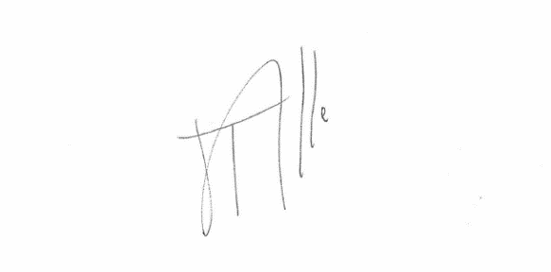
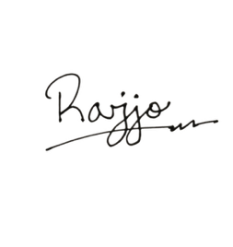

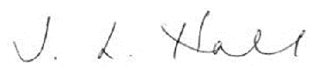

Professor Julie Hall Tijs Broeke Rajjo Mondol
Vice Chancellor Chair of the Board of Governors SU President

