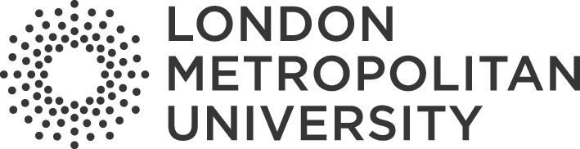

Notice and Takedown Policy
Library Services and Special Collections

Document Control Information
Version control | [ Version 2.0]  [Head of Academic Liaison & Content] [April 2025]  [ VC at SLT Meeting]  [ 16.04.2025]  [ 16.4.2025]  [April 2027]
Owned by:
Latest amendment on:
Approved by:
Approved on:
Coming into effect on:
Review date:

- Notice and Takedown Policy

Content added to our webpages and online catalogue has received due diligence checks for intellectual property and ownership rights. It has been shared to support educational research and provide wider access to our collections online. However, if you are concerned that there may have been a breach of your intellectual property and/or ownership rights, please do email library@londonmet.ac.uk and include the following information:
  - Your name and contact details
  - The URL and description of the content you wish to challenge
  - Evidence that you are the rights holder or their authorised representative
  - The reason for your request
On notification of a possible breach, the work in question will be made unavailable for public access, and then further examined in response to the enquiry. We will acknowledge receipt of your enquiry by email. Once further checks have been performed to assess the validity of the case, the claimant will be contacted with a response.

