Information Management Policy Framework

Document Control Information
Version control | 2.0
Owned by: | Director of IT Services
Latest amendment on: | 24th October 2025
Approved by: | VC at SLT meeting
Approved on: | 24th October 2025
Coming into effect on: | 24th October 2025
Review date: | 30th September 2028

Introduction

London Metropolitan University’s Information Management policy framework for staff and students comprises of 7 policies:

- London Met Acceptable Use Policy
- London Met Data Protection Policy
- London Met Records Management Policy
- London Met IT Security Policy
- London Met IT Equipment Policy
- London Met Software Policy
- London Met AI Policy

Relationship

These policies operate across the University starting with the Acceptable Use Policy which rests on the Data Protection and Records Management policies. They in turn depend upon the IT Security Policy which is underpinned by the Software, IT Equipment and AI policies. These relationships are depicted here:

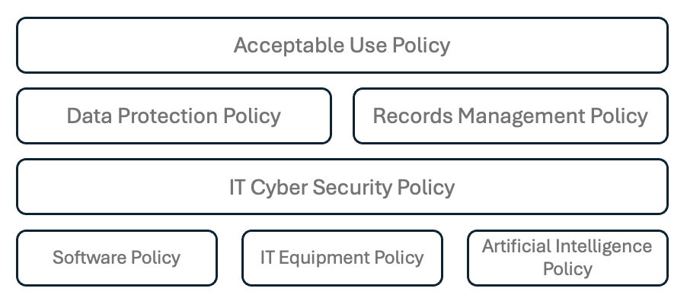

Formal Guidance

IT Services apply this framework of policies in day-to-day operation using supporting Formal Guidance documents. This document suite is not detailed within the Information Management policies due to the level of detail and the need for ongoing management. These documents are provided on the Staff and Student Zones and can be made available to staff and students on request.

These documents are approved by the Director of IT Services and reviewed annually by the IT Strategy Steering Group. Documents relating to Information Compliance will also be reviewed and approved by the Information Compliance Committee (ICC).

Freedom of Information Speech and Academic Freedom

London Metropolitan University recognises the paramount importance of Freedom of Speech and Academic Freedom. The University acknowledges their vital role in fostering a culture of vigorous and open debate within the law while being mindful of the University’s values as stated in its Strategy. While these freedoms encompass even unpopular or challenging ideas, they do not extend to violence, threats, intimidation, or discriminatory speech. We champion honest dialogue, respectful engagement with diverse viewpoints, and responsible expression within a safe and inclusive community. Our detailed Freedom of Speech Code of Practice provides further guidance on upholding these principles. In the event of a conflict between the contents of this policy and the Freedom of Speech Code of Practice, the provisions of the Freedom of Speech Code of Practice will prevail.

Breach of Policy

Infringing these regulations may result in sanctions under the University’s staff disciplinary processes or general student regulations.
Information about infringement may be passed to appropriate law enforcement agencies, and any other organisations whose regulations you have breached.
London Metropolitan University reserves the right to recover from you any costs incurred as a result of your infringement.

You must inform IT Services if you become aware of any infringement of these regulations.

