TOWER COMPLEX FIRE EVACUATION PLAN

April 2016

Because of the size and spread of the Tower Complex it is not practical or desirable to evacuate the whole complex in the event of a fire alarm.

The Evacuation Plan is based on the four coloured way-finding zones; RED; GREEN; BLUE and YELLOW and only the colour zone affected will be evacuated.

Figure 1 – Tower Complex Colour Zones

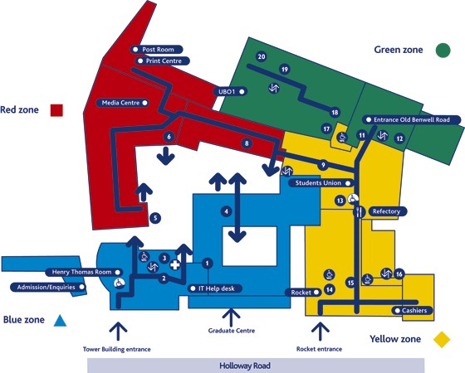

If the fire alarm is activated in any one zone it will only sound in that zone. The zones are sufficiently separated to allow people to remain in the three unaffected zones. In the unlikely event of a fire developing beyond the boundary of one zone the fire alarm will be operated in all the zones from the security control room.

TOWER COMPLEX FIRE INSTRUCTIONS

The fire alarm is a loud bell ringing nearby.

(In the Rocket offices and bars a “banshee” siren will be heard.)

A faint bell should be ignored as it will not be in your zone.

NEVER ENTER A ZONE WHERE THE FIRE ALARM IS SOUNDING.

ON HEARING THE FIRE ALARM IN YOUR ZONE
- Leave by the nearest exit
- Do not make a detour to collect belongings
- Do not use lifts
- Go to the designated assembly point.
- Report anyone unable to exit (injured or disabled) to a fire marshal (Front of House Staff wearing high visibility jacket)

ON DISCOVERING A FIRE
- Alert anyone nearby
- Immediately raise the alarm by operating the nearest break glass call point
- Leave the building by the nearest exit.
- Do not attempt to fight the fire unless you have been trained to do so.
- Report location of fire and anyone unable to exit (injured or disabled) to a fire marshal.
BLUE ZONE ASSEMBLY POINTS
RED ZONE ASSEMBLY POINTS
GREEN ZONE ASSEMBLY POINTS
YELLOW ZONE ASSEMBLY POINTS

