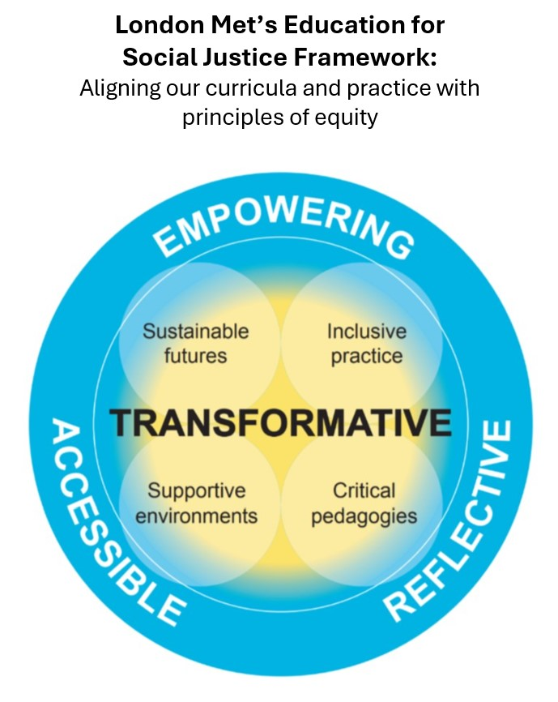


In 2019, London Met launched its new University Strategy, reaffirming its commitment to social justice, social mobility, and transformative education. Reflecting its diverse student community and role in tackling systemic inequalities—notably degree awarding gaps—the University developed the Education for Social Justice Framework (ESJF) to embed equity in learning and teaching.
The ESJF is a holistic, values-based model grounded in research, theory, and best practice. Its updated Wheel provides clearer guidance for applying inclusive curriculum principles across the institution. Rooted in inclusive pedagogy and inspired by Paulo Freire’s liberatory education, the Framework challenges deficit-based models and promotes systemic transformation to ensure that every student can realise their potential.
Our ESJF promotes critical reflection, co-creation with students, and transformative learning experiences that empower students as agents of change.
You can find out more information about the ESJF in the Teaching Success Hub here

Understanding and Applying the ESJ Framework using the ESJF Tool:
ESJF Principles
Ultimately, our ESJF aims to foster a higher education environment where every student can thrive. These are articulated through the use of the ESJF Toolkit which can be accessed here. The principles are summarised below.
Principle 1: An Accessible Curriculum -  A curriculum that places students at the heart of the learning experience | Principle 2: A Reflective Curriculum - Enable students to see themselves reflected in the curriculum | Principle 3: An Empowering Curriculum - Equip students with the skills to positively contribute to and work in a global and diverse world
Accessibility in the curriculum means removing barriers so that all students—regardless of ability or background—have equal opportunities to succeed. This ESJF Principle seeks to do this by encouraging staff to think about: | Central to the ESJF’s goal of fostering inclusive, equitable education and encouraging both staff and students to examine their beliefs, biases, and practices, this ESJF Principle seeks to encourage staff to think about: | To empower students, we must embed principles of equity, access, and fairness into the curriculum, providing students with the skills required to positively contribute to the world. This ESJF Principle seeks to do this by encouraging staff to think about:
- Inclusive Design: Creating a curriculum that considers physical, cognitive, and emotional needs, ensuring full participation for every learner.  - Universal Design for Learning (UDL): A key model that supports flexible teaching strategies, diverse learning formats, and adaptable materials to meet a wide range of student needs.  - Multiple Means of Engagement: Using varied activities, collaborative work, and personalised approaches to keep students motivated and involved.  - Flexible Assessment: Allowing students to demonstrate their knowledge in different ways—such as writing, speaking, or creative projects—based on their strengths.  - Inclusive Pedagogy: Employing teaching practices like differentiated instruction and assistive technologies to support all learners, including those with disabilities.  - Barrier Removal: Proactively addressing obstacles in learning environments—physical, cognitive, and emotional—to enable full access and participation.  - Long-Term Benefits: Enhancing inclusion leads to improved student outcomes, stronger engagement, and more supportive learning communities. | - Critical Reflection: Regular evaluation of personal assumptions and teaching practices to uncover and address inequities in the learning environment.  - Challenging Norms: Questioning existing structures and norms that may perpetuate bias, and ensuring all perspectives are included and respected.  - Inclusive Practice: Adapting teaching methods to meet the diverse needs of all learners, including those with disabilities.  - Reflective Activities: Incorporating tools like journaling, peer feedback, and discussions to deepen reflection and promote growth.  - Professional Development: Supporting staff with training and resources to enhance reflective teaching practices.  - Reflective Assessment: Using methods such as self-assessments, essays, and portfolios to help students demonstrate personal and academic growth. | - Inclusive Education: Ensuring equal access to resources and opportunities, using teaching methods that support diverse learning needs.  - Critical Engagement: Encouraging students to reflect on societal structures and their impact on marginalised communities.  - Cultural Relevance: Integrating diverse histories and perspectives, and valuing student identity and lived experiences.  - Student Agency: Empowering students to express their views, take ownership of their learning, and engage in social change.  - Curriculum Design: Promoting project-based, interdisciplinary learning and offering professional development to support social justice teaching.  - Assessment Innovation: Using reflective and authentic assessments (e.g. portfolios, essays) that builds students skills and expertise.  - Long-term Vision: Fostering empathetic, informed, and active citizens by embedding social justice at the heart of education.

Using the ESJF Toolkit in validation/revalidation
The ESJF Toolkit and Resources can be accessed on London Met’s Teaching Success Hub. Colleagues are able to download the Toolkit and use the reflective prompts to consider the questions outlined above.

For the purposes of summarising at the point of validation/revalidation, colleagues can use the template below to provide a brief statement on how the ESJF principles are realised.

ESJF Principle | Provide a brief statement considering the sections above and the reflective prompts in the ESJF Toolkit
Principle 1
An Accessible Curriculum - A curriculum that places students at the heart of the learning experience

Principle 2
A Reflective Curriculum - Enable students to see themselves reflected in the curriculum

Principle 3
An Empowering Curriculum - Equip students with the skills to positively contribute to and work in a global and diverse world

If you require further information, help or guidance on applying the ESJF, please contact cte@londonmet.ac.uk

