Education for Social Justice (ESJ) Framework

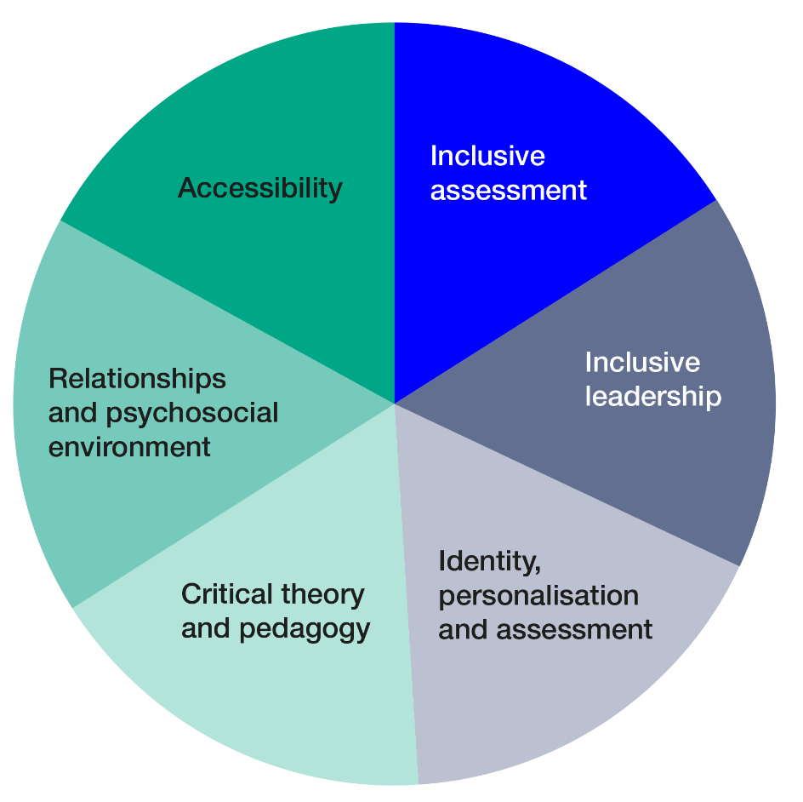
In November 2019 London Met launched its new University Strategy. It reaffirms our position and commitment to social justice and social mobility. We are an institution with a deep social purpose, we are proud of the diversity of our students and of the positive contribution we make to London.
The ESJ is the means through which we will deliver our strategy through the curriculum. Our ambition with the framework is that it will focus our pedagogy for a wider purpose, undertaking an unlearning and relearning of the World we live in and the reimaging of an equitable future together in partnership with our students.
The ESJ will encourage us to consider the impact of our choices in learning design, it will also lead to the transformation of structures so that every student can fulfil their potential.
Below are selected aspects of the ESJF which we should make steps to incorporate into our teaching and learning.

Understanding and Applying the ESJ Framework in our Curricula

INCLUSIVE ASSESSMENT
As powerful drivers of learning, assessment and feedback are key means through which to engage our diverse students in processes that support their development, success and employability, while connecting with their own identities, experiences and cultural capital.
Key Aspects | Provide a brief statement, consider the points below (bullet points are to be deleted)
Student expectation and student voice | - how assignments reflect our student cohort  - how students are involved in the review and design of assessment (co-creation)  - what opportunities there are to celebrate milestones so as to reduce assessment anxiety and develop student confidence
Purpose of assessment | - how are you facilitating students’ understanding of the assessment requirements and marking criteria  - how does assessments contribute towards employability
Methods of assessment, fairness and inclusivity | - is there a variety of assessment methods and how do these methods accommodate different learning styles  - Is there a balanced assessment load (vs over-assessment) and is there scope for continuous assessment, allowing space for students to catch up?
Accessibility of assessment | - is there scope for flexibility / choice of methods within a particular assignment?  - how does the timing and sequencing, space and pace of assessment accommodate our student body
Feedback on assessment | - what opportunities are there for developmental feedback?  - when and how is feedback provided, is it timely enough to be of benefit to all students?

INCLUSIVE LEADERSHIP
London Met seeks to “produce graduates who are inclusive in their own careers and practice, going on to become successful [inclusive] leaders across different sectors”
Key Aspects | Provide a brief statement, consider the points below (bullet points are to be deleted)
Concept of leadership | - what notions of leadership are explored in the course/discipline  - what opportunities are provided for our students to experience/study positive examples of leadership
Graduate Attributes and values | - how does the course help to develop our London Met Graduate Attribute  - what opportunities are created for students to explore “values” and critically reflect on their own, around issues of equality and discrimination
Curriculum embedding and linking with co/extra-curriculum | - what opportunities do students have to engage with critical enquiry into and active learning of the experiences of disadvantaged and marginalised groups  - what opportunities do they have to understand exclusionary practice in their particular disciplines

IDENTITY, PERSONALISATION and REFLECTION
All students are entitled to an education experience which validates and honours their identities and their lived experience. A relatable curriculum where students see themselves and their traditions reflected will engage them and reduce feelings of alienation within the University community. Opportunities to share our experiences encourage reflection on our individual values and understand our response to the World.
Key Aspects | Provide a brief statement, consider the points below (bullet points are to be deleted)
Belonging | - how you are facilitating enjoyment of learning
Confidence | - how you are building students’ confidence, self-efficacy and emotional resilience  - how you are creating trust and safe spaces to enable our students to express themselves and have their contributions validated
Student capital | - in what ways are you incorporating study material that reflects our students’ experiences and identities (relatable curriculum), and that can inspire engagement and life-long learning

CRITICAL THEORY and CRITICAL PEDAGOGY
In critical pedagogy, the curriculum content and process are aimed at developing students’ critical consciousness and empowering them, in turn, to stand against inequalities and become agents of social change. Academic study is imbued with a silent curriculum, laden with unspoken or implicit values and norms: we have the power to maintain the transmission of hegemonic traditions which perpetuate marginalisation – but even greater is our power to disrupt and invite our students to consciously intervene in the world.
Key Aspects | Provide a brief statement, consider the points below (bullet points are to be deleted)
Critical Theory (CT) and Social Justice | - what is the role, history and significance of CT in your discipline/s  - how is curriculum content, learning and assessment methods aligned with this “critical pedagogy” approach
Student Engagement | - how can you work with students as partners in diversifying the curriculum  - how can you bolster our students’ capacity for resilience to empower them when facing/transforming the world of work

DECOLONISING THE CURRICULUM
Decolonising’ means challenging West-centric worldviews, epistemological traditions and ideological forces that silence marginalised groups and sustain the racialised inequalities that permeate society – in order to incorporate alternative perspectives, experiences and epistemologies. It is not just about adjusting curriculum content but also, importantly, about pedagogy – democratising the learning space and involving students as co-creators of critical knowledge.
Key Aspects | Provide a brief statement, consider the points below (bullet points are to be deleted)
Student profile and partnership | - what opportunities are there for students to contribute to decolonising the curriculum, such as through offering ideas about content, pedagogy and assessment or by giving feedback on these processes
Subject content | - what provision is made to explore the purpose and history of the subject area  - does the course include a variety of perspectives and scholars from different backgrounds and examples that connect with students identities, experiences and interests
Language | - what scope is there to enable use of other languages and non-English sources
Teaching and learning | - how is your pedagogy informed by awareness of patterns of racialised attainment/awarding gaps  - how far do you include the voices and experiences of those typically "othered" and silenced in academia

RELATIONSHIPS and PSYCHO-SOCIAL ENVIRONMENT
Relationships and the University environment are key to enabling students to feel a sense of belonging at London Met and to encourage student engagement with learning and the opportunities offered by the University.
Key Aspects | Provide a brief statement, consider the points below (bullet points are to be deleted)
Induction and community building | - how does induction facilitate the building of good relations among students and teachers  - what opportunities are there for building peer relations / use of peer support
learning spaces and events | - what scope is there for course/School events that foster student belonging and engagement? (eg World Food Day, monthly breakfast club)  - how are links between the course and extra-curricular activities reinforced so as to provide students with aspiration and motivation
student support | - how do you ensure students are aware of the support available to them and know the people who provide it  - how are students encouraged to take up available support (eg open door policy, drop-in workshops, lunch-time sessions with Year Level Tutors)

ACCESSIBILITY
Accessibility is about ensuring that all aspects of teaching, learning and assessment are accessible for all students, especially those with disabilities, visible or invisible. It includes attending to cultural, linguistic and cognitive access as well as physical and technological access.
Key Aspects | Provide a brief statement, consider the points below (bullet points are to be deleted)
learning needs and styles | - how does the scheduling of teaching take into account the needs and commitments of our students and their complex lives  - what opportunities are there for choice and flexibility
online learning | - in what ways are you ensuring that online materials are accessible and provided in good time  - how are you supporting and developing students’ digital literacy  - could we introduce opportunities for “hybrid” delivery where some students can join live face-to-face sessions remotely if unable to be present (eg due to illness or caring responsibilities)

