Course validation/review: digital literacy checklist
Introduction
JISC defines digital literacy as ‘the capabilities which fit someone for living, learning and working in a digital society’ and suggests that it has six elements:
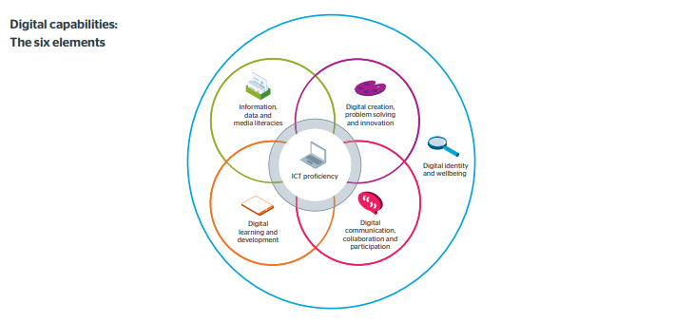
Digital literacies should be embedded within each course from the start ie. at Level 3/Level 4 of UG provision.
This checklist should be used in the process of designing new courses or modules, or revisions to existing provision to ensure the curriculum supports the development of digital literacy in an inclusive way, reflecting students’ different learning needs and learning styles.
When proposing new courses this completed document must be completed and signed off by the School’s Head of Student Experience and Academic Outcomes, prior to inclusion in the validation/review documentation forwarded to AQD.
Course or Module title: Course code (if known):

Question | Yes/No | How, and where will this be done? (Detail specific modules/Levels)  Please use bullet points to summarise key aspects or ideas  Consider the prompts for points to consider in your response and overwrite:
- 1. Does the course support the development of all relevant elements of digital capability, as defined by JISC? |  | - reflected in the teaching, learning and assessment strategy for the course  - mapping across modules – consider core modules for delivery of essential digital literacy elements
2. Does the course support a Blended learning approach? |  | - how does VLE support students’ academic and digital literacy development, e.g.  - Weblearn resources (videos, readings, simulations etc)  - discussion forums online  - synchronous online seminars  - online assessment and feedback  - lecture recordings  - engagement with course website  - online office hours  - social media groups
3. Where are digital skills first introduced to students and how are they developed as students progress through the Levels on the course? |  | - Opportunities to develop digital skills and engage in various multi-modal meaning-making activities, e.g.  - L3/L4: academic skills and library training sessions  - L3/L4: introduction to electronic platforms, digital tools, research skills, and awareness of digital etiquette  - L5/L6: further development of digital research (finding/using data, digital archives, bookmarking, referencing etc )  - L5/L6: production and communication of knowledge/design outputs using electronic platforms and digital technologies
4. Does the Course design enable students to develop digital literacy and engage with digital resources in a range of ways, and through both individual and group tasks (including formative and summative assessment items)?  [see JISC list under Q7] |  | - methods of learning, teaching and assessment e.g. learning blogs/journals, interactive web tests, computer-aided design, production of digital artefacts (e.g. videos, animations, wikis, posters, presentations, webpages, podcasts, concept maps)  - group/individual activities involving digital skills/resources  - students develop digital profiles
5. Are students required to develop an e-portfolio at any stage? If not, how is the development of their digital literacy evidenced? |  | - evidence trail re generic and subject-specific digital skills/activities
6. Is there synergy between the development of digital literacy and professional/employability skills development? |  | - students develop professional-standard and/or alternative CVs?  - engagement with professional networking sites, social media  - engagement in online job searches and other career development activities
7. Confirm that the course meets the expectations of the JISC ‘digital capability checklist’?  Students should  - Use digital tools appropriate to their subject area  - Use digital tools effectively to achieve subject-related goals  - Find, evaluate and manage digital information  - Use digital media to learn and to present the outcomes of learning  - Find, analyse and use digital data  - Create digital artefacts  - Use digital tools to gather and assess evidence, reach decisions and solve problems  - Take part in authentic digital research or professional practice  - Communicate digitally  - Collaborate digitally including with learners in other settings  - Build and participate in digital networks  - Develop digital learning skills and habits eg note-making, referencing, tagging, curation, review  - Support, mentor, coach or develop others using digital media or resources  - Develop and manage their digital identity  - Consider their digital safety and identity |  | - To what extent does the course develop deeper understanding of the concept and importance of digital literacy and the range of digital capabilities relevant to the subject area?

Created by: | Name | School | Course | Date
Course Leader
Approved by: | Name | Signature |  | Date
School Head of Student Experience and Academic Outcomes

